Shabbos Stories for
Parshas vayeishev 5778
Volume 9, Issue 13 21 Kislev 5778/ December 9, 2017
Printed L’illuy nishmas Nechama bas R’ Noach, a”h

For a free subscription, please forward your request to keren18@juno.com

It Once Happened
Remembering Mama

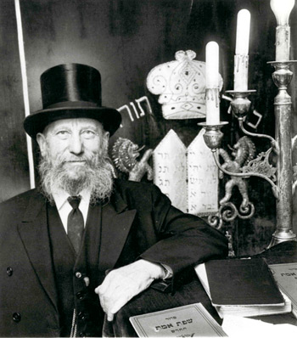
Rabbi Eliezer Silver, zt”l

The Holocaust brought with it the unique situation that many Jewish children were actually saved from death by being placed in Christian orphanages. This was not specifically a missionary effort on the part of the churches. Rather, in an attempt to save the lives of their children, desperate parents chose this path.
The war ended and with it one chapter of the Nazi horrors. An organization was founded to find lost relatives and reunite shattered families. Slowly, news reached these rescue workers that many Jewish children were living in Christian orphanages. They weren't sure of the exact numbers but they knew that it was probably in the thousands.
Rabbi Eliezer Silver (president of Vaad Hatzalah Rescue Committee that he had formed in 1939 to save Jews from the Holocaust) traveled throughout Europe to find these children and return them to their people.
The rabbi went to the first orphanage on his list and asked to speak with the head Priest. He was received with a polite smile. "Of course," explained the priest, "we have nothing against returning the Jewish children to their parents, their family, or at least their people." Hardly had the rabbi expected his mission to be so easy.
"However," the priest continued, "how do you know which boy or girl is Jewish? We don't write down a child's origin or religion when they enter the orphanage."
"You can just give me the list of names," explained the rabbi. "I'll go over the list and if it is a Jewish last name I'll know that the child is a Jew. "
"No. We don't do things like that," scolded the priest. "We have to be very precise and careful. There can be no room for error here. I must have 100% assurance and no less."
"Let's look, for instance at the name 'Miller,'" continued the priest. "You would say right away that this is a Jewish sounding name. But there are many people who aren't Jewish but still have the last name, 'Miller.' The same is true with 'Reichman' and 'Deitsch.' These are popular names amongst the Germans and Polish. We cannot release children just because they have Jewish sounding names."
What could Rabbi Silver do? Most of the children were left in this and other orphanages when they were just toddlers, or younger. They certainly wouldn't be able to remember their origin.
"I am very sorry," said the priest with irritation, "but I have spent enough time with you already on this matter. I am willing to give you not more than three minutes of my time."
How could the rabbi possibly come up with a way to save all of these Jewish children in just three minutes? According to his information, there were dozens of Jewish children in this very orphanage. Quietly, Rabbi Silver asked, "Can I have our three minutes whenever I want?"
"Yes," came the reply.
"Good," sighed the rabbi in relief. "I will come just before the children go to bed."
"That will be at seven o'clock," the priest informed him. And with that, Rabbi Silver left until the evening.
The clock chimed seven times exactly and the children, who were used to their daily schedule, lay down in their beds in the large room.
Rabbi Silver entered. He stood up on a small chair in the center of the room and waited. Utter silence pervaded the room. From every corner, the eyes of young children stared at him.
And then, in a soft voice, the rabbi said just six words that could be heard throughout the room. "Shema Yisrael Hashem Elokeinu Hashem Echad."
An instant later tender voices, whimpering, crying softly, "Mommy, Mommy," filled the room. Each child, in his own language, began searching for his mother. A mother who, years before, when she had put him down to sleep, and pulled the blanket snugly around him, and kissed him good-night, had whispered quietly in his ears these dear words which lay at the foundation of our faith. Words that every Jewish child knew, "Hear O Israel, the L-rd is our G-d, the L-rd is One."
The priest lowered his eyes in surrender. The rabbi had won. He had located the lost children. The few seconds that their mothers had set aside each evening before they went to sleep is what saved them from conversion and assimilation.
This scene, according to Rabbi Silver's granddaughter, Judy Silver-Shapiro, repeated itself in many orphanages and DP camps throughout post-war Europe. "Zaidi went to Catholic orphanages all over post-war Europe to rescue living Jewish children, and in the morning when the priests or nuns told him that there were no Jewish children, he decided to return at night when they were about to go to sleep. As he entered the large room of (non-existent) Jewish refugee children, he resolutely recited the Shema, and they all joined in the prayer. He told the priests at each orphanage that 'these are my children.' He left every single orphanage with Jewish children."
A similar story is told about Dayan Yishai Grunfeld, who walked through camps housing children who had been brought over to the UK by an inter-denominational hospitality committee from the liberated countries of Europe.
Shared his son, Rabbi Rafael Grunfeld, "As my father walked through the camp - where he had been told that there was not a single Jewish child - he began to recite aloud 'Shema Yisrael' and 'Hamalach Hagoel.' All at once he was surrounded by hordes of little children. 'Mama, Mama,' they cried. 'Take us home to Mama.'

Reprinted from the Parshat Chayei Sarah 5778 edition of L’Chaim Weekly, a publication of the Lubavitch Youth Organization in Brooklyn, NY.

Marriage
Rabbi Gifter Always Bought His
Wife Flowers for Her Birthday
By Naamah Green

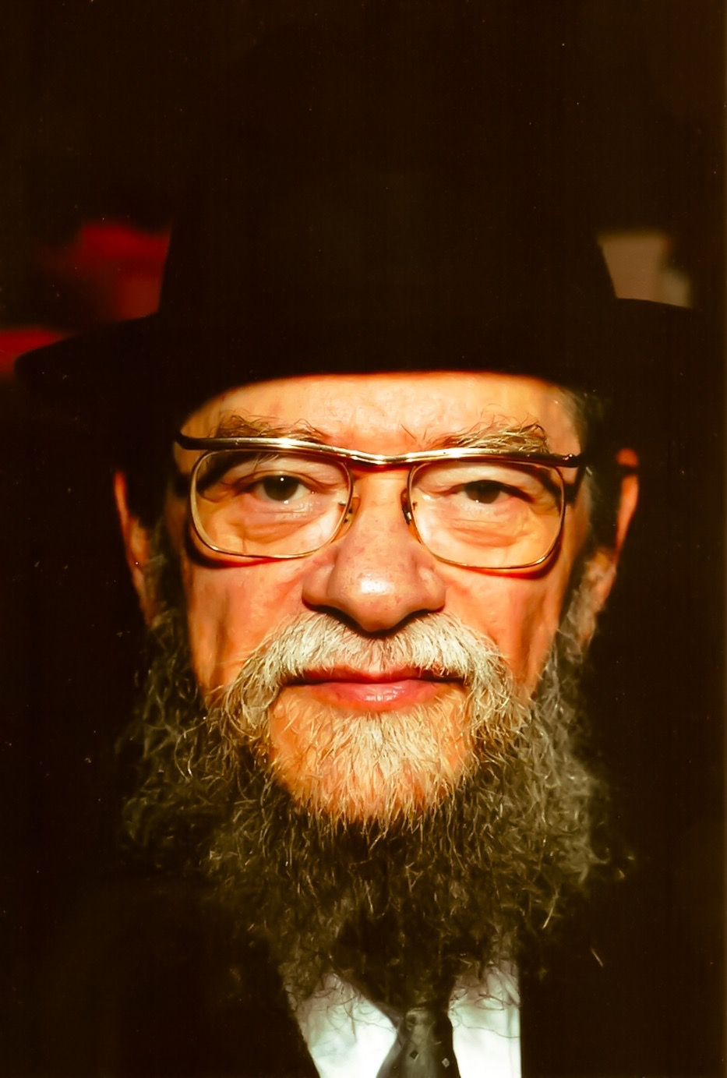

In the days before Yom Kippur Rabbi Mordechai Gifter was really working hard on his spiritual growth. His children relate that he would sit at the table trembling from the fear of G-d’s judgment and would not take part in idle chatter. But his wife’s birthday was in this same time period and buying flowers for her birthday was not something insignificant. He took it very seriously and every Yom Kippur eve he would make sure to buy her flowers in honor of her birthday.
When he completed his afternoon prayers before the festive meal before Yom Kippur he would ask a student to drive him to the florist and he’d come home with a bouquet of flowers for his wife. Every Yom Kippur the table was adorned with flowers for her.
When he became ill and needed a wheelchair to get around he sent someone to buy the flowers and he made sure he held them while in his wheelchair and delivered them into his wife’s hands. A year later when he was considerably weaker he put the flowers on his lap and rolled in to give them to his wife.
When he could no longer move she went out and bought silk flowers and she showed them to him telling him that she was continuing his noble custom of getting flowers for her birthday. The vase with the silk flowers still adorns the table. When the flowers get dusty his wife washes them so they’re bright again for the past 15 years since Rabbi Gifter’s death. May his memory be blessed.

Reprinted from the Parshat Vayishlach 5778 website of Hidabroot.

For Our Best
By Rabbi David Ashear

The Sefer Ki Ata Imadi brings a story of a couple, Reuven and Gittel, who were hiding out in their attic during the Holocaust. One of their gentile neighbors supplied them with food, and another neighbor agreed to raise their two children as their own to protect them from the Nazis, yimach shemam. Reuven and Gittel lived in constant fear and worried about their children's spirituality, growing up in a home devoid of religion.

One day they were told about a man named Stefan who was accepting money to smuggle families to Switzerland. Reuven risked his life to go meet Stefan at a coffee shop. He was told that each person would cost 15,000 francs. So for him, his wife and two children, it would be 60,000.
Stefan told him there was a train leaving next Thursday. If he could come up with the money by Wednesday, he'll take them. Reuven went home and told his wife, but they had no idea how they would come up with such an exorbitant amount of money. They sold everything they had including his wife's expensive jewelry, and they managed to come up with 50,000 francs.
They were hoping Stefan would take them for that, or at least allow them to owe the other 10,000. They had relatives in Switzerland who would gladly lend them the money. But the next Wednesday when Reuven went back to the coffee shop at the designated time and told Stefan that he had only 50,000 francs, Stefan said, "No way, I will not do it for one franc less than 60,000."
Reuven and Gittel thought they were getting out. They had so much hope, and now they were right back to where they were before. They strengthened each other in Emunah, however, accepting the will of Hashem, telling themselves, "If Hashem didn't allow us to leave now, then it is for our best to be here."
Baruch Hashem, they survived the war and were reunited with both of their children. Later, they found out that the people who Stefan took that Thursday were all caught, including him, and were all put to death, lo alenu.
The Sefer Ki Ata Imadi asks: If Hashem was going to save Reuven and his family anyway, why did He first give them false hope? Why did He make them sell all their possessions, when He knew they weren't going to use that money anyway?
Of course, we can never fully understand the ways of Hashem, but the rabbi suggested that sometimes Hashem wants to give a person a gift or a Yeshua(salvation), but at the moment the person is still not worthy of it. So, Hashem will put him in a situation that will require a lot of Emunah to accept, and if the person rises to the challenge and accepts the Will of Hashem lovingly, that will provide him with the merits necessary to receive the gift that Hashem wanted to give him.
We find this concept, he says, in the Parasha of Tzaraat on the houses. Chazal tell us, sometimes Hashem caused Tzaraat to come upon a person's house, so the house would be demolished, and the homeowner would find hidden treasures behind the walls.
And the question was asked: If Hashem wanted to give a person a treasure, why did He have to do it in seemingly such a harsh way? When the person discovered what looked like Tzaraat on his home, he had to empty out his entire house, all the furniture and possessions.
The Kohen would come and inspect the house. The Kohen would then quarantine it, and the homeowner would have to move out with his family and ask others if he could stay by their house. And when it was finally decided that it was Tzaraat, the entire home had to be demolished. Why couldn't Hashem just give them the treasure without all of this? And the answer, the rabbi says, is the same as he said before. Hashem wants to give people gifts sometimes, but in their current situation they're not worthy. So He gives them a difficulty to deal with. And when they accept it with Emunah, they become worthy of those gifts.
Of course, any difficulty anybody encounters was coming to him either way, it's just that Hashem times it to come at a time when the person needs the merits of Emunah. We never know exactly why anything happens; we don't know why each challenge is given. But we do know that responding with Emunah is the best possible response we can have and will definitely bring blessing one way or another.

Reprinted from the November 23, 2017 email of Daily Emunah.

Anti-Semitism
By Rabbi Yirmiyahu Ullman


From: Jason in Buffalo, NY

Dear Rabbi, Why is there so much anti-Semitism and anti-Jewish sentiment in the world?

Dear Jason, I will try to offer a logical explanation, although I personally believe there is a mystical reason as well. Many different forms of Jew-hatred spring up from time to time. Several different reasons lie behind them. These include: 1) Jealousy towards us for having the original Bible 2) Anger at our continued resistance to being converted 3) Ideological clash
But why is it so prevalent in many parts of the world and in many cultures? Why are the Jews always the bad guys? Other nations and religions guilty of the same “crimes” are not victim to this hatred to the extent that we are.
To trace the roots of anti-Semitism we must journey back over 3,300 years to the revelation at Mount Sinai. Before presenting the Torah to the Jews, G-d offered it to all the other peoples of the world. It was up for grabs; yet every nation turned the offer down. They simply weren’t willing to change their lifestyles in order to accommodate the Torah into their daily living.
When the Jews accepted the Torah, the jealousy of the nations was aroused. “They now have an advantage that we neglected and we can never forgive them for it.” We have something that the other nations lack. We were chosen for the task to be G-d’s “emissaries” to the rest of the world.
Exemplary, Torah-true lives should impact on others and cause them to draw closer to G-d. Nobody likes being told what to do, and the flag that we wave flaps irritatingly in their faces. We represent a threat to them, an irritating reminder that maybe they should be striving for higher things.
This hatred frequently lies dormant in the subconscious, flaring up when an excuse can be found. Often it’s intensified at times when we enjoy material success. The Jew in the Mercedes “runs them down”! Not only do we have the audacity to advocate a Torah; we also have the chutzpah to live luxurious lives. The State of Israel especially is a thorn in the side of many of our enemies. From the brink of annihilation in the Holocaust we have risen to become a modern, relatively wealthy nation with a powerful military. The paupers from the shtetl are now high-tech tycoons.
Is anti-Semitism only a bad thing? Strange as it may sound, it may also be the best thing that the non-Jew has ever bequeathed us with! Should it happen that we begin to neglect our responsibilities as Jews, G-d nudges us to remind us who we are and what we are doing here.
Anti-Semitism works as “shock treatment”. Never forget that you are a Jew. And a Jew has duties that may never be abandoned. Nowadays, too, the problems that are rapidly escalating are a signal from G-d. Let us take this warning to heart, and do what we can to strengthen ourselves.

Reprinted from the Parshat Vayeitzei 5778 email of OHRNET, the Ohr Somayach Torah Magazine of the Internet.
Hashgacha Pratis #16

One Last Chance
By Rabbi Paysach J. Krohn

David Haber runs a successful curtain and window treatment business in downtown Boston. At times, his phone lines, like his home, seem like a raucous whirlwind of activity, as David is not only a businessman. Aside from being a devoted husband and father to six children, he is involved with local community affairs and with many national and international tzedakah organizations.
One night he had an appointment with a Mrs. Silver to show her swatches of fabric and to discuss window treatment options. David did not keep the appointment; he simply forgot about it as, in his frenetic schedule, he had neglected to enter it into his appointment book.
That night at 10 pm, an irate Mrs. Silver left a blistering message on his office answering machine. David called her, honestly explaining that he was simply overworked and forgot, asking for her forgiveness.
But Mrs. Silver was not in a forgiving mood; she insisted that as a businessman he should have been more responsible, and that her time was just as valuable as his.
David again apologized and said, “Please, give me another appointment and let me make amends. And this time, I promise I will be there on time.”
Mrs. Silver was not a religious Jew and David was concerned that his failure to show up at her home, aside from being poor business practice, was a chillul Hashem.
There was a long pause; David thought she had disconnected the line. Then she said reluctantly, “One Jew should always give another Jew a chance. You can come Monday morning at ten and I expect you to be on time.”
David gave her his assurance. David arrived at her home at 9:55 am. He rang the doorbell and waited. The door opened in a flash and a teenaged girl started screaming hysterically, “What are you doing here? I didn’t call you. You don’t belong here!”
David was shocked. “I have an appointment with Mrs. Silver. Is this her home?”
The girl cried, “My mother just collapsed in the kitchen. We’re waiting for an ambulance. I think she had a stroke!”
David, who was a mainstay of Hatzalah of Boston, cried, “I’m a medic,” and ran to his car to retrieve his equipment. He saw at once that Mrs. Silver was barely breathing. Her neck muscles had become paralyzed and her tongue, which had fallen back, was not allowing her to breathe.
David quickly opened up an air passage and got her to resume breathing. He saved her life! A few days later when David visited Mrs. Silver in the hospital she said to him, “I thought I was the one giving you one more chance, but I realize now, that it was you who gave me one more chance – at life.” (Echoes of the Maggid)

Reprinted from the Parshas Vayishlach 5778 email of The Weekly Vort.

L’Maaseh
The Power of Recognizing
A True Tzadik

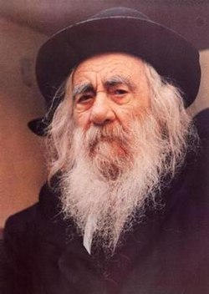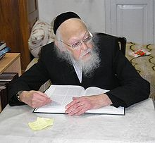
The Steipler Gaon, zt”l Rav Yosef Shalom Elyashiv

Rabbi Aryeh Ginzberg relates a story:
“A few weeks after I arrived in Eretz Yisroel in 1974 to learn in Yeshivah, I received a heartfelt letter from a Kollel fellow I knew. The letter detailed the difficulties that he and his wife were undergoing, as her last three pregnancies had ended in miscarriages and doctors could not identify the cause.
The couple had heard about a Mekubal who dispensed bottles of water which were rumored to prevent miscarriages. Since I was the only one he knew living in Eretz Yisroel at the time, he asked if I could try to obtain a few bottles of this water from the Mekubal and send them to him.
In those days, the trip would have taken at least six hours. Moreover, with the inevitable long lines by the Mekubal, I could expect the trip to take all day. I wasn’t sure what to do. Should I give up an entire day of learning in Yeshivah for this act of Chesed?


Rabbi Aryeh Ginzberg

When I asked the Mashgiach of the Yeshivah for advice, he recommended that I present the question to a Posek in Mei’ah She’arim, who at the time was not known outside of the small circle of Talmidei Chachamim in Yerushalayim. His name was Rav Yosef Shalom Elyashiv.
I went to see Rav Elyashiv and when he heard my She’eilah, he said, ‘I am not personally familiar with the practice of dispensing water as a Segulah, nor with the people who do so. However, there is a concept in Chazal, that if a Tzadik makes a decree, Hashem carries out the decree. Therefore, if a true Tzadik decrees that if one drinks from a certain cup of water and Brachos will come from it, then I strongly suggest he drink to the very last drop!’
I then asked who, in his opinion, fits Chazal’s description of a ‘Tzadik’. Without any hesitation he said, ‘The Steipler Gaon’, who was the father of Rav Chaim Kanievsky and also Rav Elyashiv’s Mechutan.
Since the Steipler lived in Bnei Brak, which was less than an hour from Yerushalayim, Rav Elyashiv suggested I travel there to obtain a Brachah for this young couple. I immediately traveled to Bnei Brak, with a letter from Rav Elyashiv which introduced me and stated the purpose of my visit.
When I showed the letter to the Gabbaim, I was immediately allowed to be seen by the Steipler. After the Steipler read the letter, he smiled and said, ‘You are coming from Rav Elyashiv. Do you know who Rav Elyashiv is? All of his Halachic decisions come from Shamayim!’ The Steipler then gave his Brachah.
On the ride back to Yerushalayim I contemplated the words that the ‘Tzadik of the generation’ had just shared with me, that the unassuming man in Mei’ah She’arim was completely and totally dedicated to Torah, and his Halachic decisions come from Shamayim itself.
At that moment, I decided to spend as much time as I could with this great and holy man and absorb what I could from him. I visited with Rav Elyashiv several times a week, and ultimately, I was Bentched with the great Zechus of having a regular learning Seder with him every Motzaei Shabbos!
Incidentally, approximately twenty years later, I was granted the honor of reciting a Brachah under the Chupah at this young couple’s oldest daughter’s wedding, as the Brachah from the Steipler was fulfilled about a year after I went to him!”

Reprinted from the Parshas Vayeitzei 5778 email of Torah U’Tefilah: A Collection of Inspiring Insights compiled by Rabbi Yehuda Winzelberg.

Why Rabbi Yaakov Kaminetsky Returned to the Hospital

In the summer of 1954, Rebbetzin Itta Ettil Kaminetsky, O”BM, left Beth Israel Hospital, for the last time, after a prolonged stay. Her condition had deteriorated, and the doctors felt that there was nothing left for them to do.
Rabbi Yaakov Kaminetsky, O”BM, went together with family members to pick up his Rebbetzin up from the hospital. The Rebbetzin was wheeled to the waiting automobile and made as comfortable as possible.
Suddenly, Reb Yaakov seemed to realize that he had forgotten something important. He whispered something to his wife, and when she nodded her approval, he asked if it was possible for the driver to wait a few minutes. He had to go back into the hospital.
The family members were a bit surprised. Although there was another patient in the room, and items may have been confused, they remembered removing every one of the Rebbetzin’s personal belongings from the room.

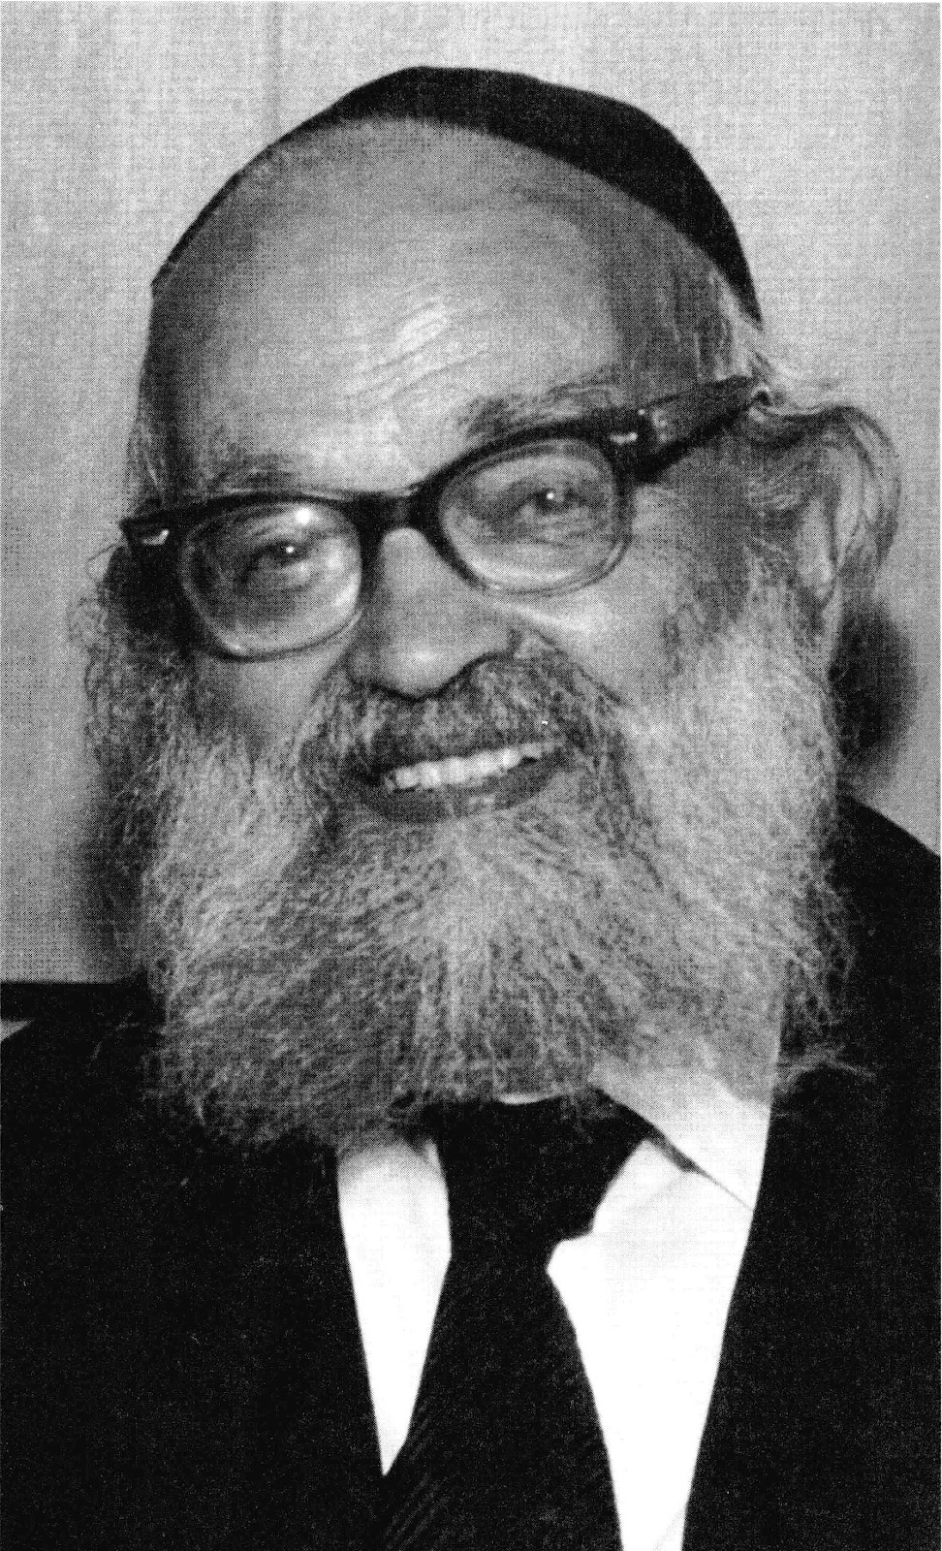

Accompanied by his curious son, Reb Yaakov proceeded to the elevator and pushed the button to the floor on which his wife had stayed. “Pa,” his son protested, “we have everything.”
The elevator stopped at the correct floor. Reb Yaakov proceeded into his wife’s former room and turned to her ailing roommate: “In our rush to leave the hospital, I forgot to tell you good-bye and wish you well. May G-d send you a speedy recovery.”
With that, Reb Yaakov walked out of the room, nodded at the stunned nurses, whom he already had thanked on his first exit, and left toward the waiting car.
Reprinted from the Parshas Vayishlach 5778 email of Torah Sweets Weekly.

The Golden-Ruble Sheepskin
By Blumah Wineberg

In the days of the Baal Shem Tov, there lived a G-d-fearing Torah scholar who earned his livelihood as an innkeeper. He leased a tavern on one of the estates of one Count Potozki. Fortune did not smile kindly on him. For two years, he was not able to pay his rent. The count warned him that if he did not pay off his debt in the third year, he and his family would soon taste the vengeance that was common among the local squires in those days. The entire household of the poor man was plunged into misery. There seemed to be no hope for them.
One day, his good wife said: “Listen, my dear husband, I’ve heard that not too far from here, there lives a holy rabbi who has helped many people in distress. His name is the Baal Shem Tov. My advice to you is that you travel to him and tell him all about our situation. Do exactly what he tells you to do, and G-d will surely help us through this.”
At first, the innkeeper refused. He was no chassid, and he did not understand how the Baal Shem Tov could help. But the wife persisted in her request, until eventually he agreed to go. He set out with a heavy heart to the Baal Shem Tov, to whom he described his terrible plight.

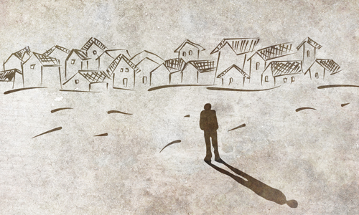

The Baal Shem Tov advised him: “Go for a stroll in the street on Sunday morning, and when you are approached by a villager who offers to sell you something, buy it at once. Take absolutely no notice of what the object is, or whether it is worth the price the villager asks for it. Then come to visit me again, and I will tell you what to do with your purchase.”
This sounded like a bitter jest to the poor man. He had never been one to believe in wonders and miracles. He had no intention of carrying out the strange instructions of the Baal Shem Tov.
When he came home, his wife asked him what the tzadik advised him to do. When he told her, she insisted that he do exactly what the tzadik advised. When Sunday morning came, she gently encouraged him to go for a stroll. Immediately, the man saw the words of the tzaddik coming to life—a villager approached him and offered to sell him the fleece of a sheep. He asked how much it would cost, and the villager answered, “One gold ruble.”
So astonished was the man at what was happening that without a second thought, he handed over the last gold ruble he owned and took the fleece.
Immediately, the man regretted the transaction. He went home vexed and disgruntled, and burst out to his wife: “Look what I’ve earned by listening to your advice. What on earth can I possibly do with a fleece? And I went and spent my last gold ruble on it! What will become of us now?”
His wife answered him, “Don’t you recognize that the Baal Shem Tov is a man of G-d? Haven’t you seen with your own eyes that no word of his is said in vain? Why don’t you go back and visit the holy man again, just as he told you to. Surely G-d will come to our aid.”
Her husband had no choice, so he went. The Baal Shem Tov heard his account of what had transpired with the villager and said: “My son, you did the right thing by buying the fleece. Now, take note of what I tell you. In a few days, a great number of nobles will be coming to visit your count for his birthday. Each one will bring a gift. You go along on the same day and present him with the fleece as a birthday gift.”
Was the Baal Shem Tov making fun of him? he thought. What a preposterous suggestion! How could he do a thing like that? He came home and let his wife know how he felt.
His wife, however, was a woman of faith. “Does it not say in the holy books that you should not try to figure out things that are beyond the reach of our humble mortal understanding? All you should do is carry out whatever the Baal Shem Tov told you to do and be strong in your faith in G-d who works through the tzadik,” she said.
On the day of the count’s birthday party, the innkeeper’s wife bustled him out of the house with the fleece over his shoulder. His heart was heavy with foreboding and his steps trembled with terror as he made his way to the count’s castle.
The many elaborate carriages surrounding the palatial home bespoke the nobility inside celebrating the count’s birthday. The poor innkeeper paused at the door, not knowing what to do. Should he go inside and garner the wrath of his landlord, or turn back and go home? He had just about decided to go home when the massive door opened and one of the count’s guards sized him up and shouted: “Jew! What are you carrying? Did you come here to bring a present to the count as well?”
In his bewilderment, he held out the fleece. The guard grabbed it from his hand and hurried inside with it. He showed it to the count and all the assembled guests.
“This,” he announced, “is a gift from the Jew who rents the inn on the count’s estate!”
The count was furious. He had the Jew thrown into his prison, while contemplating this riddle.
“Can it be that this man would have the nerve to insult me in the middle of my festivities?” he questioned, as if speaking to himself. “Surely no man hands himself over to be killed.”
The count rose from the table, still holding the fleece, and secluded himself in his room. Perhaps there was something special about this strange gift. As he gazed upon it, he saw what appeared to be letters in the fleece. Soon he was able to make out his name, his father’s name, and the year, the month and the day on which he was born! He was so overawed by this wondrous sight and so filled with joy!
He strode back to the reception hall and went from table to table with his prized possession, asking the guests whether they thought this was the work of a gifted craftsman or whether it was an uncanny product of nature. They were all of one opinion—no craftsman in the world could contrive such a wonder. It must be a miracle from Heaven.
The count immediately had the trembling innkeeper released and brought before him. From all sides he was asked the same question—“Where did you get a hold of such a fleece?”
The poor fellow was now convinced that death was indeed near at hand. In his desperation, he hurled himself at the feet of the count and with bitter tears told him his whole sad story.
All the nobles listened attentively, and when he fell silent, the count spoke up: “Do not fear, my good man, for the holy man sent you here for a blessing.”
He then showed him the wonder of the fleece that he had brought. The visiting nobles meanwhile decided that the count should make himself a fur hat out of this fleece. Every year thereafter, on his birthday, he should wear it and present the Jew with special gifts.
To start the tradition, all those present gave him gifts of gold and silver. The count announced that he would forego the entire debt of the preceding years.
The innkeeper was escorted from the palace with due pomp, and from that day till the end of his years, he prospered in all his ways. (Adapted from Sippurei Chassidim, Parshat Toldot)

Reprinted from the Parshat Vayeishev 5778 email of Chabad.Org Magazine.

Why Rav Kotler was Upset

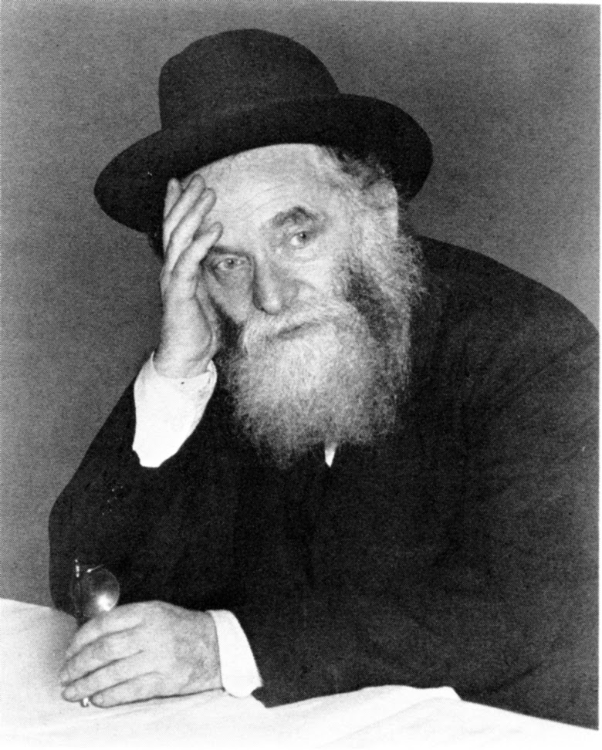

Rabbi Aharon Kotler would have to go and meet with donors to Lakewood Yeshivah. He once got a connection to a very wealthy man. They made an appointment with this man and had the meeting to discuss a large donation he was planning to give to the Yeshivah.
At the end, he decided not to make that donation. Rabbi Kotler's helpers noticed that the Rabbi looked very upset about not getting the money that he expected for the Yeshivah.
So they went over to the Rabbi to console him. "Don't worry Rabbi, we'll get the money somehow".
Rav Aharon answered, "I'm not worried about the Yeshivah because I know that we will get what we need from Hashem, but I'm concerned for this man because he just let this tremendous Zechut of supporting Torah, slip through his fingers!"

Reprinted from the Parashat Vayishlach 5778 email of Jack E. Rahmey with the Guidance and Teachings of Rabbi Amram Sananes.

